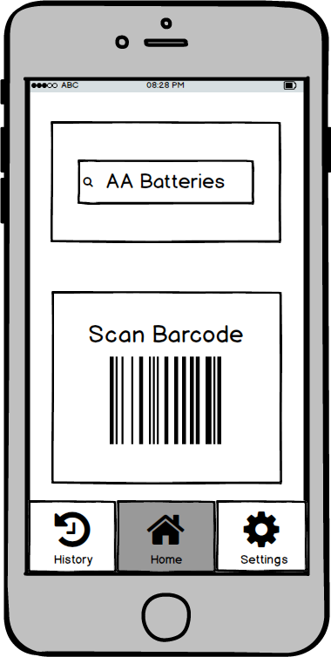

**Scon Barcode**

**3D || íỳ History Settings**